Download the Conference App
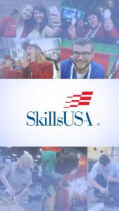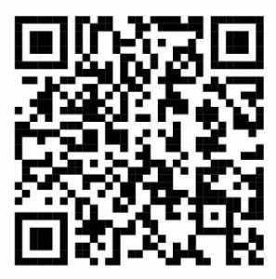
Download the app when you scan the QR code, above:

In keeping with these digital times, there will no longer be a separate printed conference program for the national conference in Louisville. All attendees should download the official conference mobile app. The app includes the entire conference program including contestant schedules, trade show information and exhibitor list, Opening and Awards Ceremony, special events, entertainment, participant tracks, attendee bus shuttle schedules, messaging/alert features and search features.
The app can be downloaded by searching “2018 SkillsUSA NLSC,” and the QR code will be in the printed Awards and Recognition book and on signs at Kentucky Exposition Center.
A condensed version of the NLSC program will be included in the printed Awards and Recognition book, available on site. In addition, there is now a PDF of this program available for download from our SkillsUSA website at: www.skillsusa.org/events-training/national-leadership-and-skills-conference/agenda/

